Cheerleading Tryouts

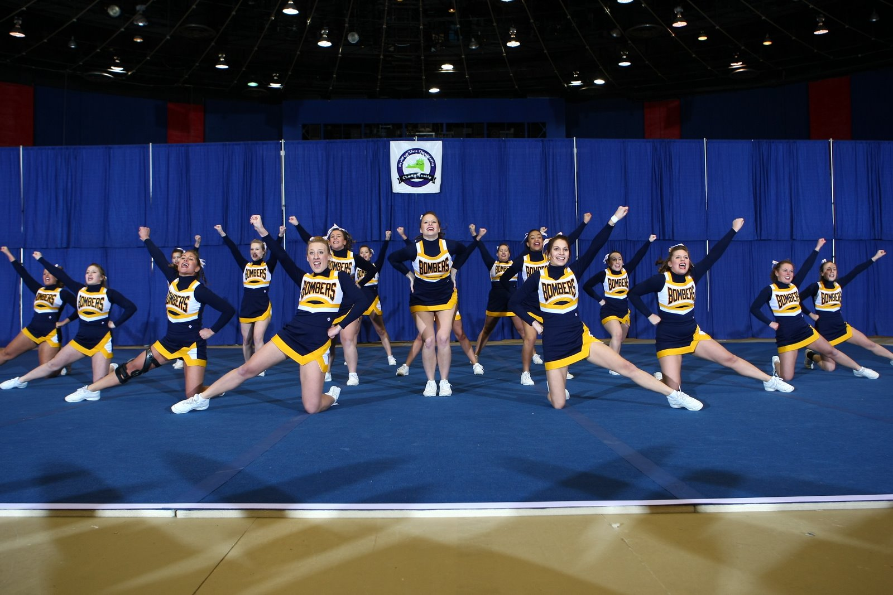

Mandatory Informational Meeting
Friday, August 28th – 4:00-5:30pm
Williams Hall – Room 317

Tryouts
Saturday, August 29th – 10:00am-3:00pm
Sunday, August 30th – 10:00am-1:00pm
Hill Center - Gymnastics Room

Details: Tryouts will be held over a two day span. The first day the material will be taught and perfected. The second day the material will be reviewed and the tryout will take place.

Any questions? Contact Jessica Sharkey at president@iccheer.com
For more details, visit http://www.iccheer.com
Sponsored by IC Recreational Sports

